**Automatic Pill Dispenser**

*Abstract - Technology has played a crucial role in all industries but its importance in the healthcare field is even more substantial. The fast paced lifestyle of millennials has calls for an automatic and smart technology that helps us to check if prescriptions are in order and the medicines are taken at the right time and right amount.The need of pill dispensers is acute since the manual intake of pills is very obsolete .So we intend to create an automatic pill dispenser that can be used by old patients and people affected with chronic diseases. The pill organizer when feeded with the pill, dispenses the required pill when needed as well as notify the sick and the caretaker about it. This is a simple Pill Reminder developed using Arduino which reminds us to take necessary medicines.*

1. **Introduction**

Fascinatingly the study on medical errors and accidents that happens frequently involves medication errors and adverse drug reactions. These errors alarmingly increases the chances of the fatality of the patients, having numerous side effects and high expenditure of the treatment. This also makes the treatment process more complex as well becomes a major disturbance for the caretakers especially of chronic patients.

The intake of numerous medications for old patients as well as the accompanying specifications of each medication does increase the risk of major accidents that can cost life. Considering all these reasons the importance of an automated system for dispensing medication is crucial and is the need of the hour . The hectic lifestyle of the working class also further increases the emergency of such a product in the industry.

Medication errors are known to occur throughout the medication use process of ordering, transcription, dispensing, and administration, with prescription errors introduced during ordering account for more than 50% of all errors. Administrative errors account for about 30-40% of all the errors that can be prevented. The dispenser is designed to eliminate the misunderstanding of medication directions and inconvenience of rigid medication schedules.

1. **Components**

|  |  |
| --- | --- |
| **Sl.No** | **Components** |
| 1 | Alert Module |
| 2 | Power Supply |
| 3 | LCD display |
| 4 | GSM 900 Module |
| 5 | Microcontroller |
| 6 | Servo |
| 7 | Ultrasonic controller |
| 8 | RTC Module |

1. **Design**

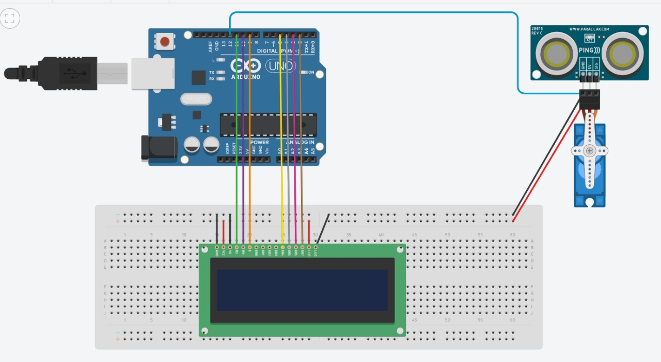

1. **Working**

**Basic Working** - Pill dispenser involves the use of an ultrasonic sensor depending on which the dispenser dispenses pills to the patient. The sensor is active for a certain period of time after the alert message has been sent to the user. The dispenser keeps a track of the amount of pills left in stock and displays it on an LCD. This is governed by initially setting the number of pills placed in the dispenser and at each activation period.

4.1 Alert Module

The alert module is a combination of a GSM sim900 module which has a sim card mounted. This enables us to alert the patient via text SMS.

4.2 Power Supply

A power supply provides electric power to an electric board. It regulates the current from the source to an appropriate voltage, current and frequency to power the load. The ideal input voltage to power an Arduino is 7V - 12V with an ideal output current of 200 mA.

4.3 LCD Display

The 16x2 display used is a basic display device that finds various applications over the 7 segment display. It can display 16 characters over 2 lines and each character is displayed in a 5x7 pixel matrix. The module works with 2 basic registers command and data.

4.4 GSM 900 Module

A GSM module works on various frequencies. GSM 900 works with a quad-band frequency of 900MHz. It can not only be used to access the internet but also for oral communication. The module is managed by AMR926EJ-S processor which controls phone and data communication

4.5 Microcontroller

Amongst the various microcontrollers available in the market to control a device, Arduino is an open source hardware and software company that provides microcontrollers which can sense and control objects or components in real world.It consists of Atmel 8 bit microcontroller with different availability of flash RAM.The open source nature allows the publication of various free software libraries.Here the Arduino is used to control the functioning of GSM 900, Servo, LCD display, RTC module and the ultrasonic sensor.

4.6 Servo

A servo is a device that aids in rotatory motion with precise angle, acceleration and velocity through a motor coupled to a sensor with feedback.The angle that the shaft of the servo moves to can be controlled through Arduino in terms of degree it rotates to. In this area servo finds application to rotate the medicine box with a hole at the top to dispense the medicines stored in the box by rotating at different angles varying with the medicine to be dispensed.

4.7 Ultrasonic Sensor

An ultrasonic sensor is used to measure the distance between an object through ultrasonic waves. The sensor emits ultrasonic waves and receives the reflected waves from the object. The distance between the objects is measured through the time taken to receive the waves after emission.

4.8 RTC Module

An RTC module is a real time clock. It is based on DS1307 i.e. it is a lower power consumer, full binary-coded decimal (BCD) clock with 56B of NV RAM it follows I2C and bidirectional bus protocol for transmission of address and data. The clock/calendar is automatically adjusted for a month less than 31 days but needs to be reset for months with 31 days. It works in 12 or 24hr format in AM/PM format. The DS1307 has a built-in power-sense circuit that detects power failures and automatically switches to the backup supply.The basic idea to use the RTC module in this application is to sync the system to real time to send a message to the user at the exact time when his medicine is due.

1. **Conclusion**

The pill dispenser provides a means of regular medication at regular time intervals. The dispenser makes sure that the user is alerted every time he/she needs to take a dose, this way the patient and the caretaker need not worry about setting reminders for his/her daily medicine schedule. Moreover, the automated system makes sure that the right amount of dosage is being consumed by the user and this rules out the possibility of over and under dosage.

1. **References**

1.<https://circuitdigest.com/microcontroller-projects/arduino-medicine-reminder>

2.<https://drive.google.com/file/d/1I_3BCwreQVIGZtWhk9UhjRF6Bl1A51xA/view?usp=sharing>

3.<https://drive.google.com/file/d/1qkrI5Qqu5uAsqDL8hyvZhslkoJXy0POi/view?usp=sharing>